Books

"Bass Culture: When Reggae Was King"  Lloyd Bradley  Penguin Books  While many other books I've read offer historic, in-depth analysis of the genre, Bradley's take is more through the eyes of those who make the music - Prince Buster, for instance, who wrote the forward. A very comprehensive, readable and colloquial read, it's the kind of book that takes you deep into Kingston, Brixton, Chapeltown, and other parts that few have managed to bring to life well, all the while keeping the focus on the music and those who helped it progress - at least throughout the roots period, Bradley's sphere of interest (which suits me just fine). For anyone wanting real insight into the culture behind reggae, rocksteady, and ska, this is a recommended read. | 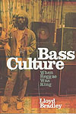
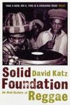 | "Solid Foundation: An Oral History of Reggae"  David Katz  Bloomsbury Publishing  With over 250 conversations and interviews, David Katz allows the pioneers and architects of Jamaican music to use their own voices to tell their unlikely tale. This book is a testament to the greatness of its originators, charting the development of the culture beat with all its glorious highlights and the controversies and feuds in between.  Solid Foundation is the history of the first thirty years of Jamaican reggae, from the pre-ska era to the dawn of dancehall.
"People Funny Boy - The Genius of Lee 'Scratch' Perry"  David Katz  Payback Press | 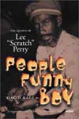
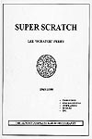 | "Super Scratch - The Almost Complete Album Discography"  Gary Simons' passionate album discography of Lee "Scratch" Perry. A must-have for anyone interested in Lee Perry's connection to the world of Jamaican music (and beyond). Thank you, Gary, for writing this book.  Self-compiled and published by Gary Simons.  available at www.eight4eight.com  or contact:  GARY SIMONS  565 BONNIE DRIVE  EL CERRITO, CALIFORNIA 94530  USA
"Reggae - The Rough Guide"  Steve Barrow & Peter Dalton  Rough Guides | 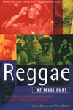

Video

"Roots Rock Reggae - Inside the Jamaican Music Scene" (1977)  produced by Jeremy Marre  Shanachie Entertainment  A personal highlight from this film is The Heptones, Junior Murvin and The Congos recording "Play On Mr. Music" in Black Ark Studios with Lee Perry at the controls. Reportedly, this performance/recording was a reaction to hearing the news of a failed attempt on Bob Marley's life. An excerpt of these few minutes are included in my playlist. | 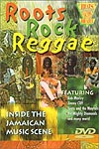
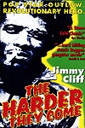 | "The Harder They Come" (1972)  starring Jimmy Cliff  directed and produced by Perry Henzell  Far from the vacationers' world of sun and surf lies the real Jamaica. Good soundtrack. A great in-studio clip of the Maytals recording "Sweet and Dandy".
"The Studio One Story" (2002)  directed by Stuart Baker  Plenty of interviews and stories from Clement "Coxsone" Dodd and many Studio One performers. | 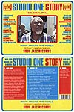
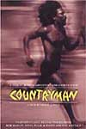 | "Countryman" (1982)  directed and story by Dickie Jobson  A nice tale about politics, money, deception, obeah and the powers of nature. Good soundtrack.
"Rockers" (1978)  directed and written by Theodoros Bafaloukos  Set within a world of poor Jamaican Rastafarians, this reggae film stars Leroy "Horsemouth" Wallace as a hustling drummer and record distributor who tries to get his stolen motorbike back from mob thugs so that he can spread the message of his music. An exceptional soundtrack, with music by Burning Spear, Bunny Wailer, Third World, Peter Tosh, Inner Circle and more. | 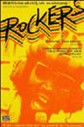
"Life & Debt" (2001)
a film by Stephanie Black
Jamaica - land of sea, sand and sun. And a prime example of the impact economic globalization can have on a developing country. Using conventional and unconventional documentary techniques, this searing film dissects the "mechanism of debt" that is destroying local agriculture and industry while substituting sweatshops and cheap imports. With a voice-over narration written by Jamaica Kincaid, adapted from her book A SMALL PLACE, LIFE AND DEBT is an unapologetic look at the "new world order," from the point of view of Jamaican workers, farmers, government and policy officials who see the reality of globalization from the ground up.
"Words, Sound & Power - Soul Syndicate Band" (1981/2005)
a film by Jeremiah Stein
A documentary about the Soul Syndicate, one of Jamaicas finest groups of reggae instrumentalists (they have provided backing for records by Bob Marley & The Wailers, Toots & The Maytals, The Heptones, Burning Spear, Jimmy Cliff, and many others). The film is unique in its blend of tension and relaxation, movement between city and the country, in its mix of good talk and good music, taking you in close to modern Jamaican music and to the ideas, experiences and emotions behind that music and Rastafarianism, which can be called politics, religion or mysticism, depending on who is doing the calling.

